DURABLE FURNITURE

Table of Contents

ACKNOWLEDGEMENT1

SYNOPSIS2

PROBLEM DEFINITION3

CUSTOMER REQUIREMENT SPECIFICATION (CRS)3

SCOPE OF THE PROJECT4

ARCHITECTURE AND DESIGN OF THE WEBSITE4

SOURCE CODE WITH COMMENTS 5

SITE MAP5

SCREENSHOTS 6

USER GUIDE6

DEVELOPERS GUIDE7

**ACKNOWLEDGEMENT**

I would like to appreciate the Lord, God Almighty for seeing me through the process of executing this project. He has always been extremely faithful.

I also want to thank my parents for their support so far, I pray that the Lord would reward them abundantly. My sincere gratitude also goes to the entirety of Aptech Computer Education, Abeokuta – right from the faculty to my colleagues for their timely professional advice and support.

I appreciate the efforts of everyone that contributed to the success of this project. God bless you all!

**SYNOPSIS**

**Durable Furnitures** is a site where you can get excellent home products that are perfect and durable.A web store that brings your imaginations to reality

with thousands of products to select from and excessive updates regularly,You will love it

We are able to design to new products customer's specification ...If you need special products,kindly give us your idea.Competitive prices and excellent service with a good reputation in the market.We believe you will not regret cooperating with us

**Durable Furnitures** website has the following features:

* Basic information about the various types of furniture.
* Gallery section for viewing different images of the various amazing furniture available .
* Contact platform with contact information and links to social media
* Implementation of Google maps for easy location of store.

**PROBLEM DEFINITION**

**Durable Furniture**  is a retail business specializing in advertising and/or selling furniture; we also show some featured products, as well as other top products that fall under the title of furniture

**CUSTOMER REQUIREMENT SPECIFICATION (CRS)**

CLIENT: Durable Furniture

BUSINESS/ PROJECT OBJECTIVE:

**Durable Furniture**  is a retail business specializing in advertising and/or selling furnitures; we also show some featured products, as well as other top products that fall under the title of furnitures

**SCOPE OF THE PROJECT**

1) The site should display a menu with following categories:

* The Home Page
* About Us
* Events
* Featured Furniture Products
* Contact
* 3) ‘About Us’ should provide details of the company and past and upcoming events.
* 4) There should be a “Contact Us” page which will have the Address of the Shop which is as follows and the mail address which when clicked will invoke the local mail client from where they can send an email. Address of the Company should be displayed using GeoLocation API (eg. GoogleMaps).

**ARCHITECTURE AND DESIGN OF THE WEBSITE**

**Durable Furniture** shop like every other website in the internet would have a client – server architecture. This implies that the project would have to be hosted on a server from which the clients (users in this case) would get access to the website.

Here is an illustration of a client – server architecture



CLIENT – SERVER ARCHITECTURE

**SITE MAP**

Below is a structure of the navigational flow of objects in the Carvan website.

As is seen in the figure, the site’s navigation takes a kind of “full mesh” structure. This means that all pages are interlinked.

Each of the pages is linked to every other page on the website and this is achieved through the consistent navigation menu.

**SCREENSHOTS**

Nobody needs to be taught how to use the internet but sometimes, it is necessary to familiarize ourselves certain environments. Two sites may have the same aims and objectives but they would surely have different modes of implementation. This is why I have decided to 

* Navigation menu

This is a normal navigation with drop downs located at the top of the page.

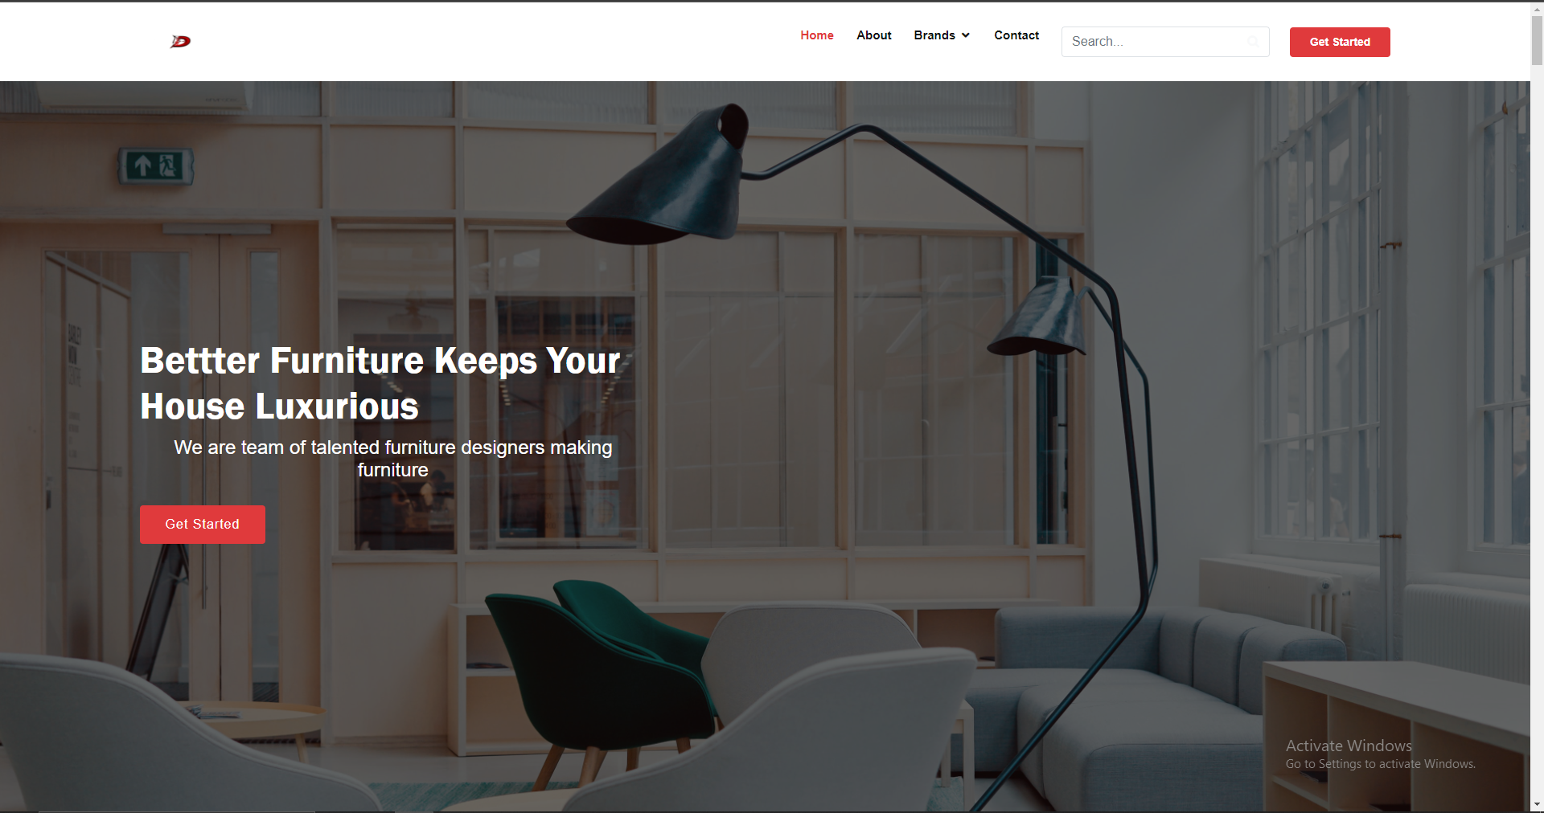

Social media links

On the left of any PC screen, transparent hover buttons are present which actually links to various social media are.

* Google Maps

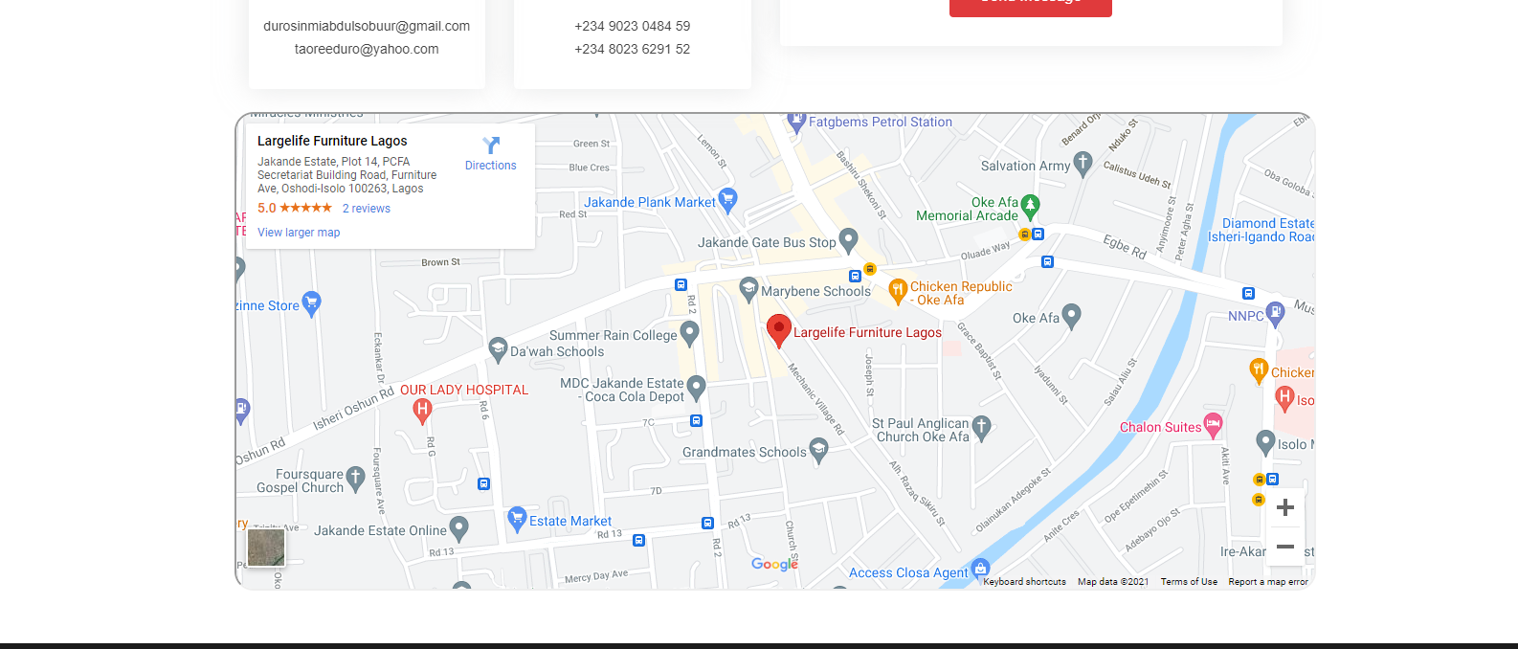

What if there’s need to contact The Cake team? There’s absolutely no problem with that as Google maps has been integrated into the website to ease that process!

* User-friendly Screenshot

All attractive web page has been added to the website to showing all the fun information of the Furniture.

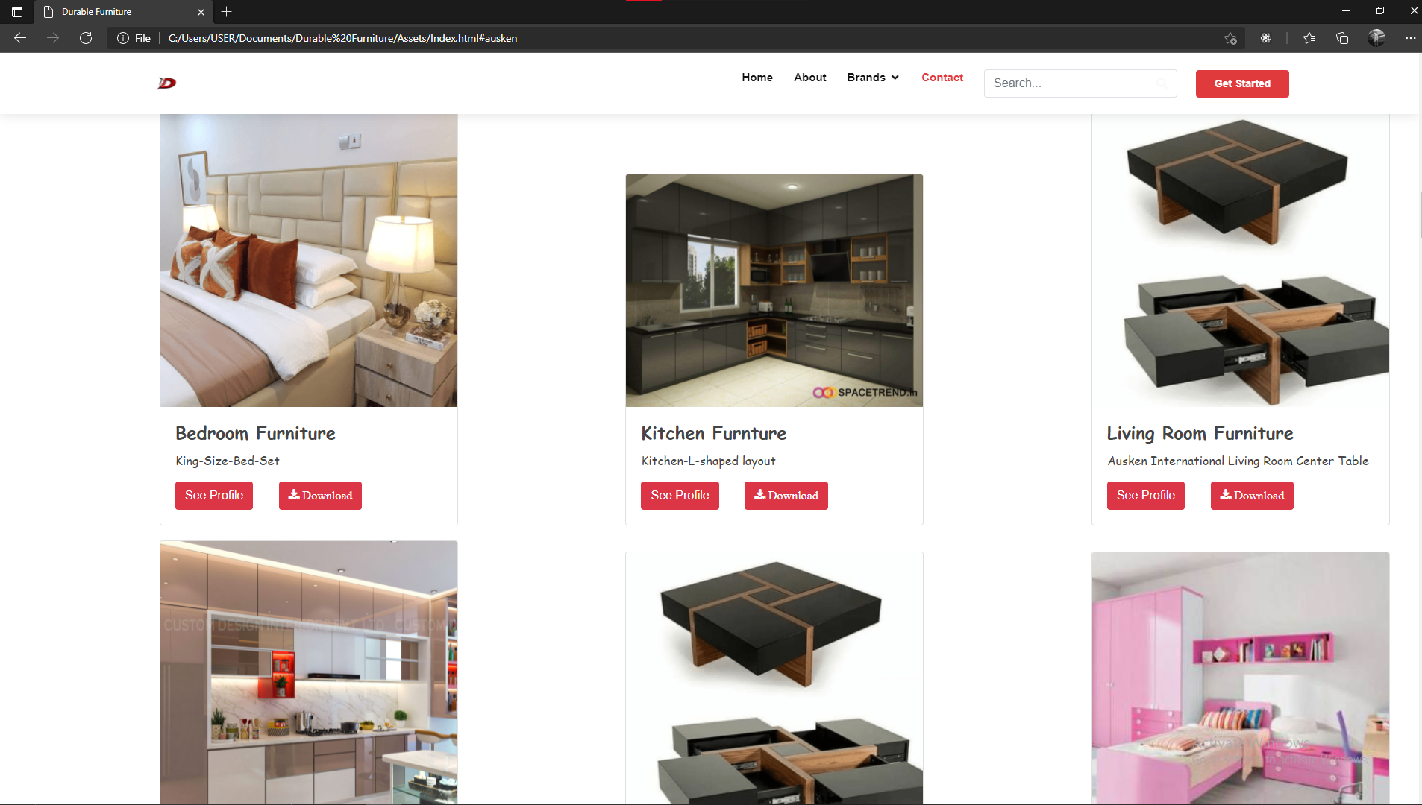

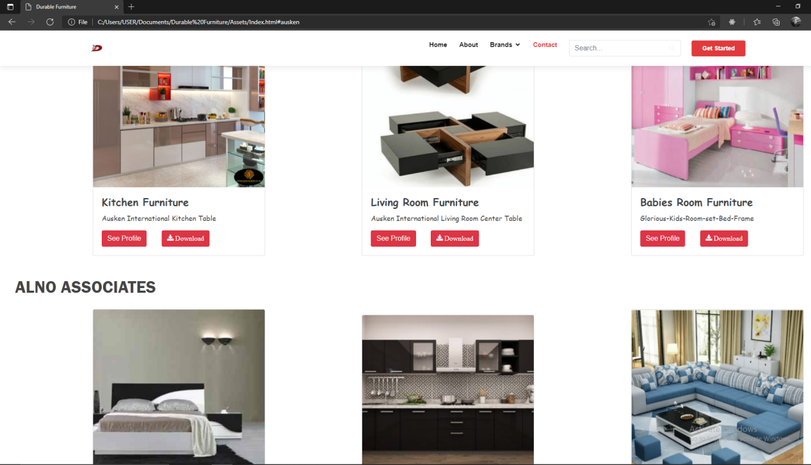

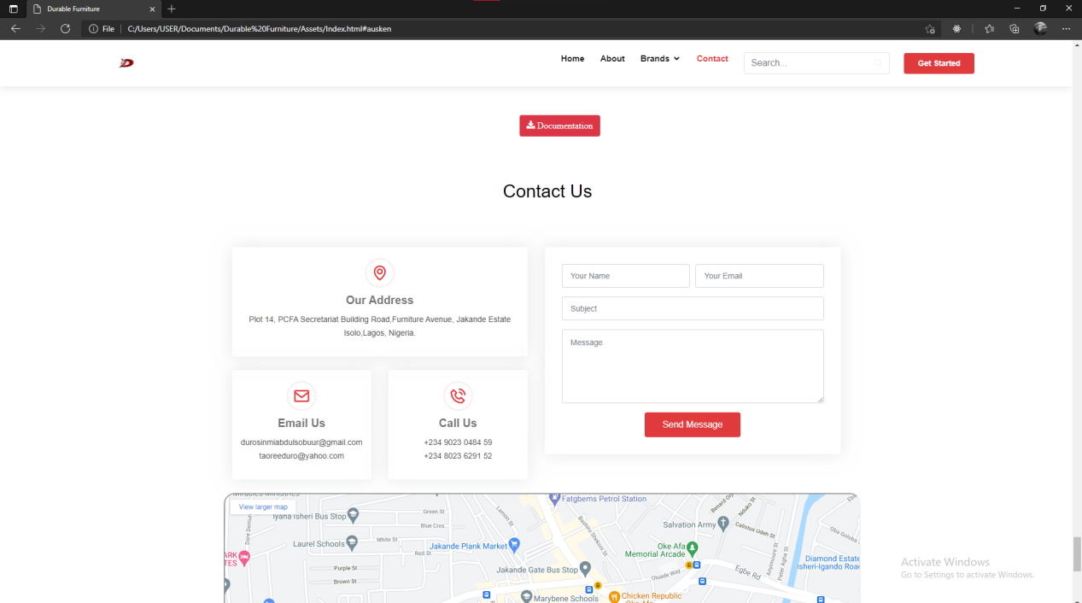

USER GUIDE

* SYSTEM REQUIREMENTS
* Operating system: Windows 7 or higher OS
* Software: HTML 5 or JavaScript supporting browsers
* GET THE WEBSITE RUNNING
* Host the website on a server
* Access the website by typing in the domain name in any HTML 5 and JavaScript supporting browser
* Navigate the website using the user-friendly navigation menu and links.